Homework 7

David Heisler

2.14

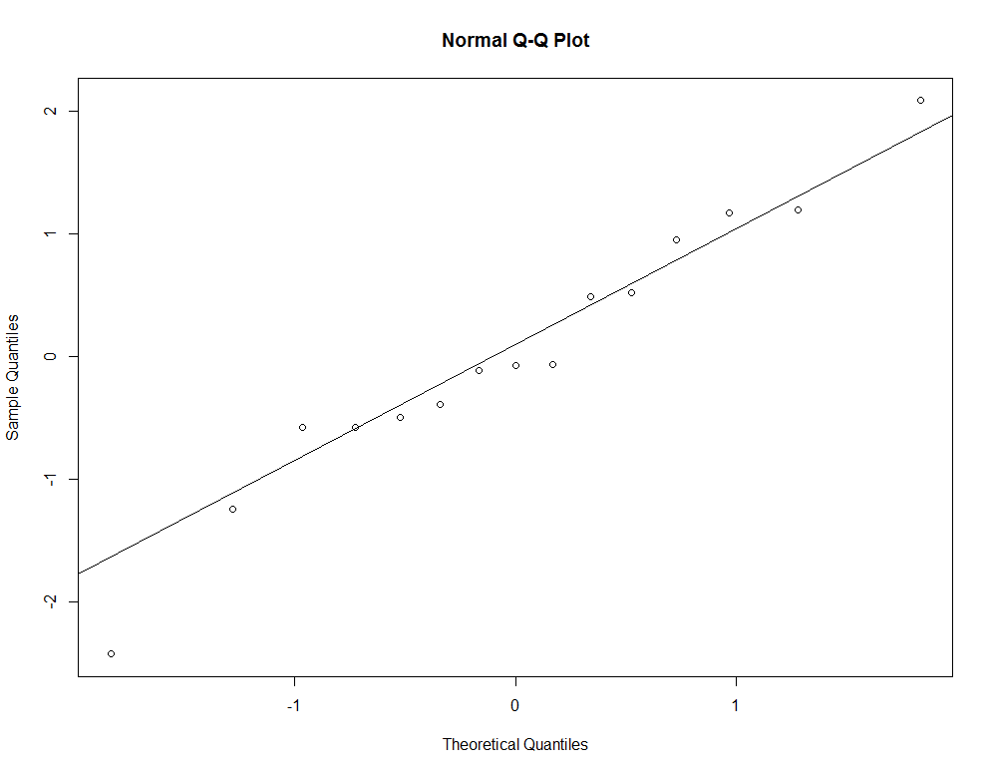a)

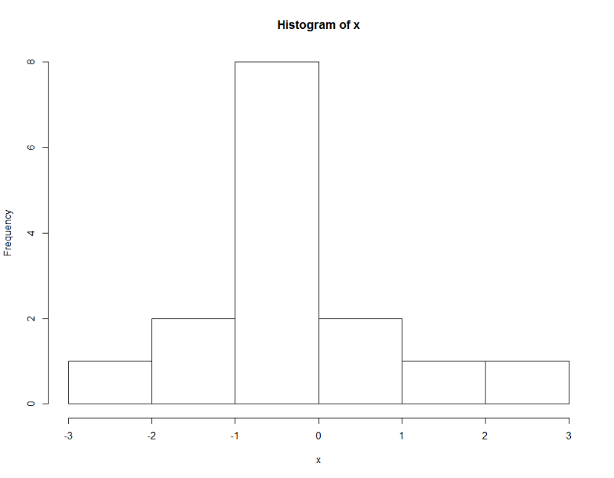

The points do seem to fall on around a straight line.

The histogram appears to be symmetric!

This makes sense, because we are drawing random samples from the N(0, 1) distribution, and this random sample should mirror a normal distribution.

b)

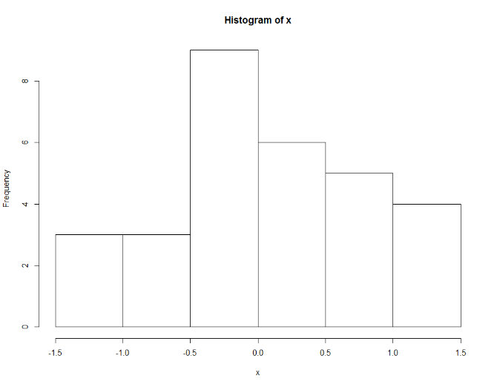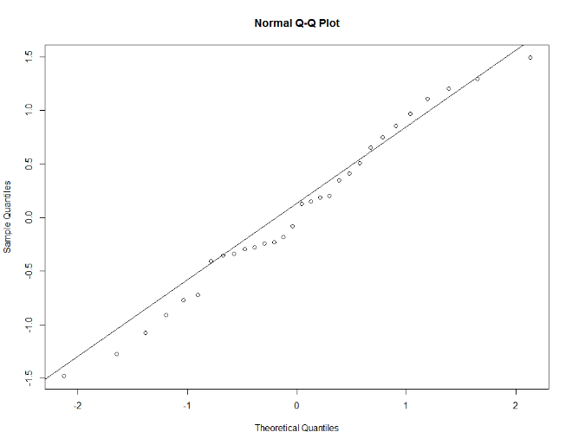n = 30; The quantities appear to be getting closer but look a little less symmetric

As mentioned above, these are reasonable because we’re drawing from N(0,1)

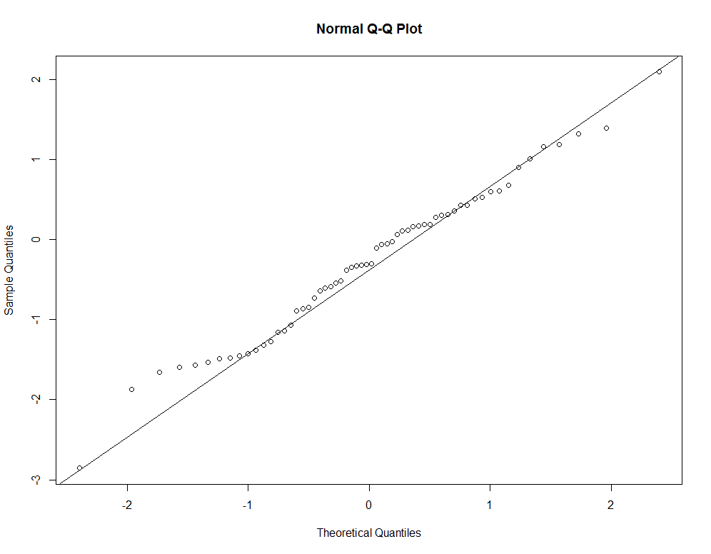 n = 60; The quantities appear to be getting closer to the line and now look more symmetric

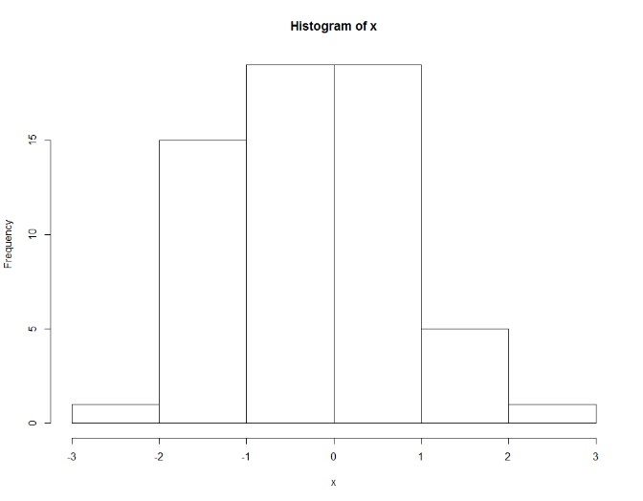

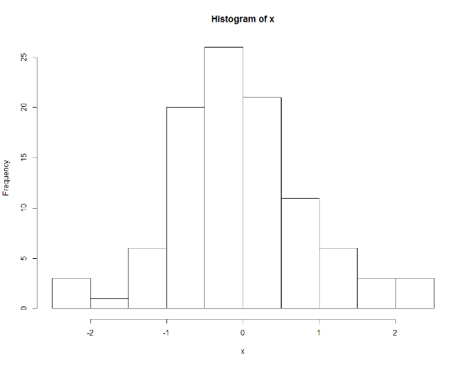n = 100; The quantities are remaining close to the line, although there is some drift on the tails. The histogram looks almost perfectly symmetric. This random sample should be the closest to being normally distributed out of all the samples, because n is largest in this sample. 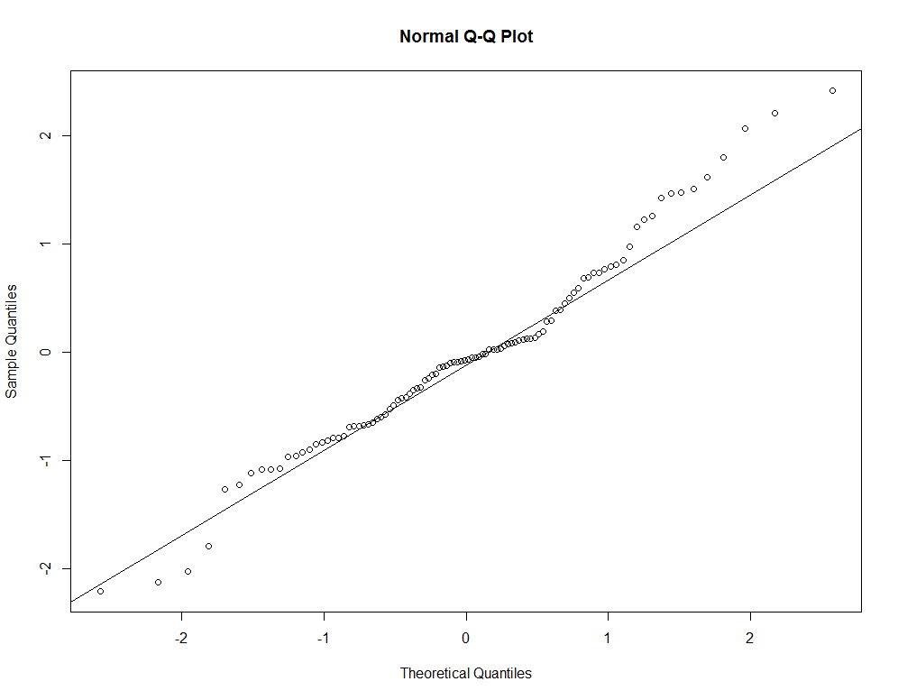

c) As I take more samples from my data, I get a better understanding if my data can be approximated using the normal distribution, thus visually confirming the CLT.

15

17

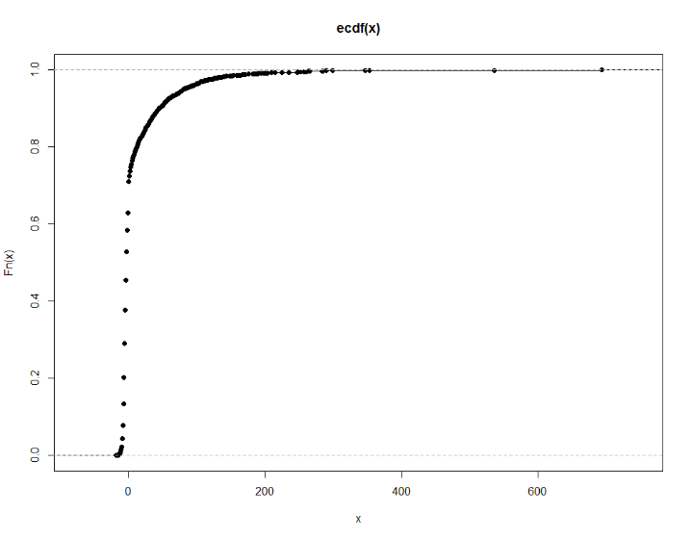American Airlines:

United Airlines:

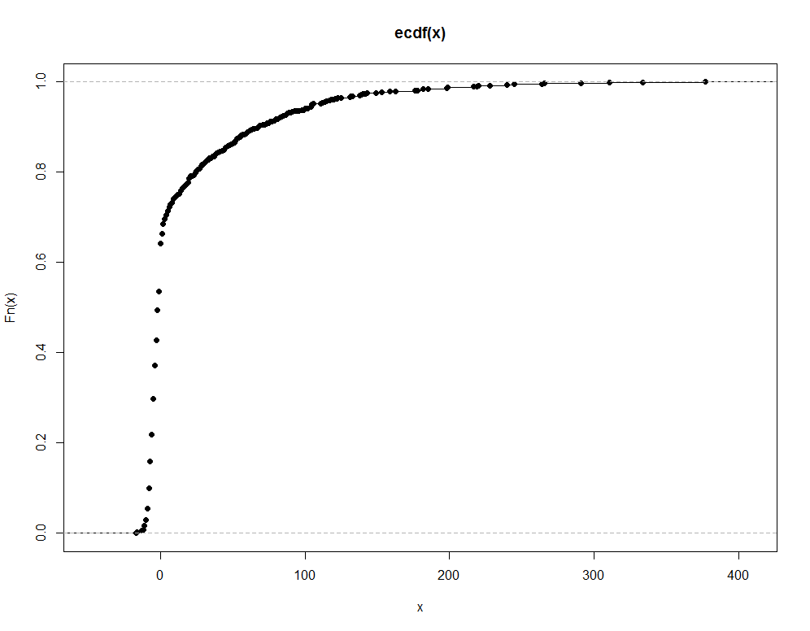

Looking closely at the two empirical cumulative distributions, we can notice a few differences. The first is the scales of the distributions. This will tell us a lot, because looking solely at the dots plotted without acknowledging the scales would lead to some misinterpretation. The scale for the UA flight delays goes from less than 0 to about 400, incrementing by 100. The scale for the AA flight delays goes from a little less than 0 to 600, incrementing by 200. It is important to note this, because the first visual difference between the two plots is how much “smoother” the UA flight delays is from after 0 to the first increment. However, the difference is that AA flight delays’ first increment is 200. If you imagined stretching out the scale of the AA flight and incrementing it by 100, you would see that the flight delays would have a similar “smooth” property from 0 to 100 as the UA flights does.